Humber River Kiosk Q&A

General Inquiries 3

What methods of payment are accepted? 3

What are the parking office hours? 4

Where is the parking office located? 6

Where can I use my H PASS? 7

Where can I purchase my H PASS? 8

Accessible parking: Where can I park? 9

Is accessible parking free? 10

I entered the wrong parking lot. 11

I can't find my car. 12

The machine says: "Ticket Unreadable" 13

The machine says: "Pass Unreadable" 14

The machine won't take my ticket 15

Report an Issue 16

Where can I park? 17

The parking lot is full, what do I do? 18

Hospital portals of care. 19

Where are the hospital information desks located? 21

Where does the parking revenue go? 22

Parking Passes 23

What kind of parking passes are offered? 23

Where can I purchase my H PASS? 24

How many days do I have left on my H PASS? 25

Can I reload my H PASS? 27

I lost my H PASS. 28

I lost my 24 hour parking pass. 29

I lost my 15 in/out parking pass. 30

How do I use my parking pass? 31

Rates And Payments 32

What are the parking rates? 32

What methods of payment are accepted? 33

Where can I pay for parking? 34

Where are the pay stations located? 35

My credit card isn't working. 36

I lost my ticket what do I do? 37

Where is my receipt? 38

I didn't receive a ticket upon entering the parking lot. 39

Can I leave using a different credit card? 40

The machine can't read my credit card 41

The machine won't take bills 42

The machine won't take my credit card 43

My credit card is stuck 44

Help Videos 45

How To Use: Gated Parking System 45

How To Use: EV Charging Stations 46

How To Use: Pay and Display meters 47

Staff Inquiries 48

Where can I park? 48

How do I register for monthly parking (I PASS)? 49

# General Inquiries

## What methods of payment are accepted?

**Parking Office and Pay Station:**

* Credit card
* Debit
* Cash

**Parking Lot Entry and Exit Terminals:**

* Credit card ONLY (no debit or interact accepted)

## What are the parking office hours?

**Monday - Friday**

7:00a.m - 11:00p.m

**Saturday - Sunday**

10:00a.m - 6:00p.m

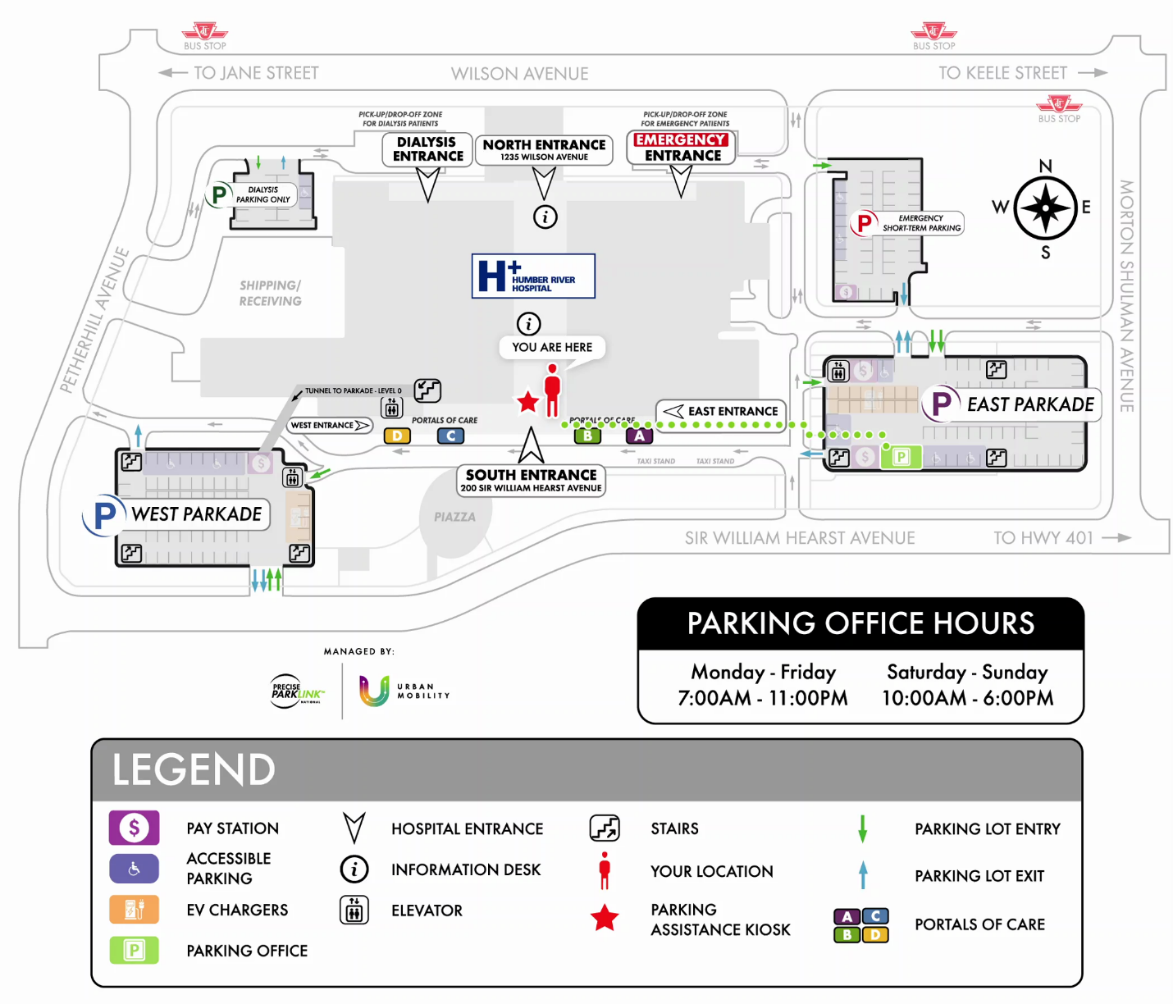

24 hour virtual assistance is available at the parking lot entry and exit terminals or pay stations. Tap the *Press for Assistance* buttons to call for help.

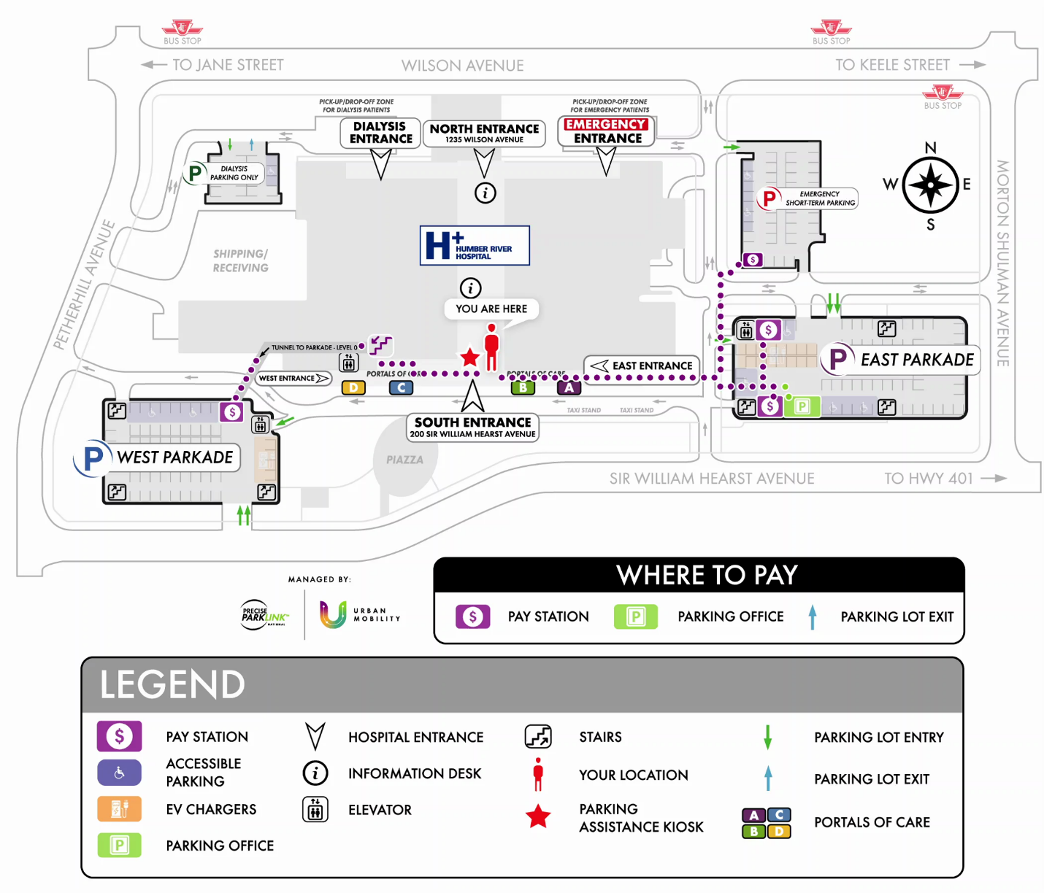

## Where is the parking office located?

The parking office is located in the southwest corner of the East Parkade.



## Where can I use my H PASS?

H PASS can be used in the East and West Parkades.

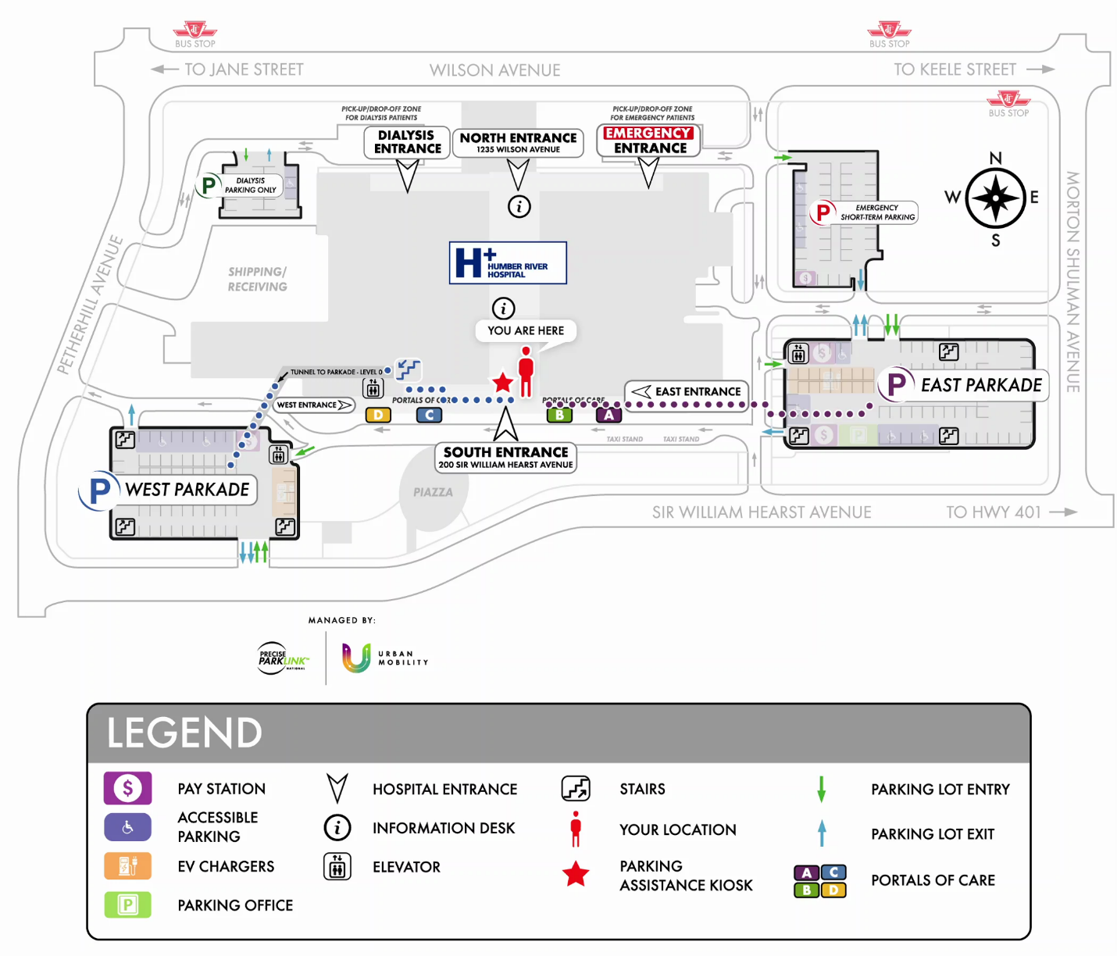

## Where can I purchase my H PASS?

You can purchase an H PASS at the parking office. The parking office is located in the south west corner of the East Parkade.



## Accessible parking: Where can I park?

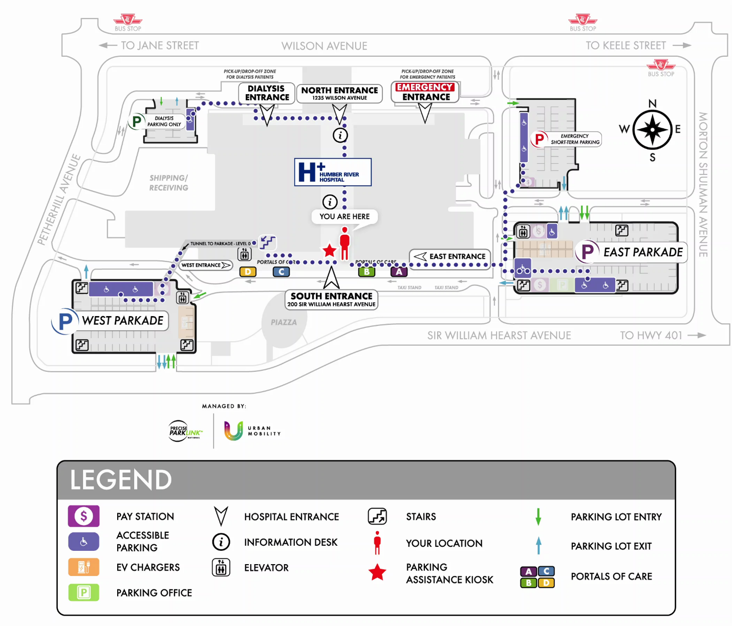

## Is accessible parking free?

Accessible parking permit holders are required to pay for parking. Your accessible parking permit allows you to park in the designated accessible parking stalls.



## I entered the wrong parking lot.

Your entry ticket will allow you to exit the parking lot within 20 minutes at no charge.

## I can't find my car.

Please visit the parking office for assistance.



## The machine says: "Ticket Unreadable"

Please re-insert your barcoded entry ticket with the arrows facing up and forward or tap the *Press for Assistance* button on the terminal.

## The machine says: "Pass Unreadable"

Please re-insert your pass with the arrows pointing forward.

## The machine won't take my ticket

Please visit the parking office for assistance.



## Report an Issue

Please visit the parking office for assistance.



## Where can I park?

Patient and visitor parking is available in the East and West Parkades.

Emergency parking is available in the Emergency, short-term parking lot.

**Hospital employee parking:**

**East Parkade**: Level 3 and 4.

**West Parkade**: Levels 2, 3, 4, 5.

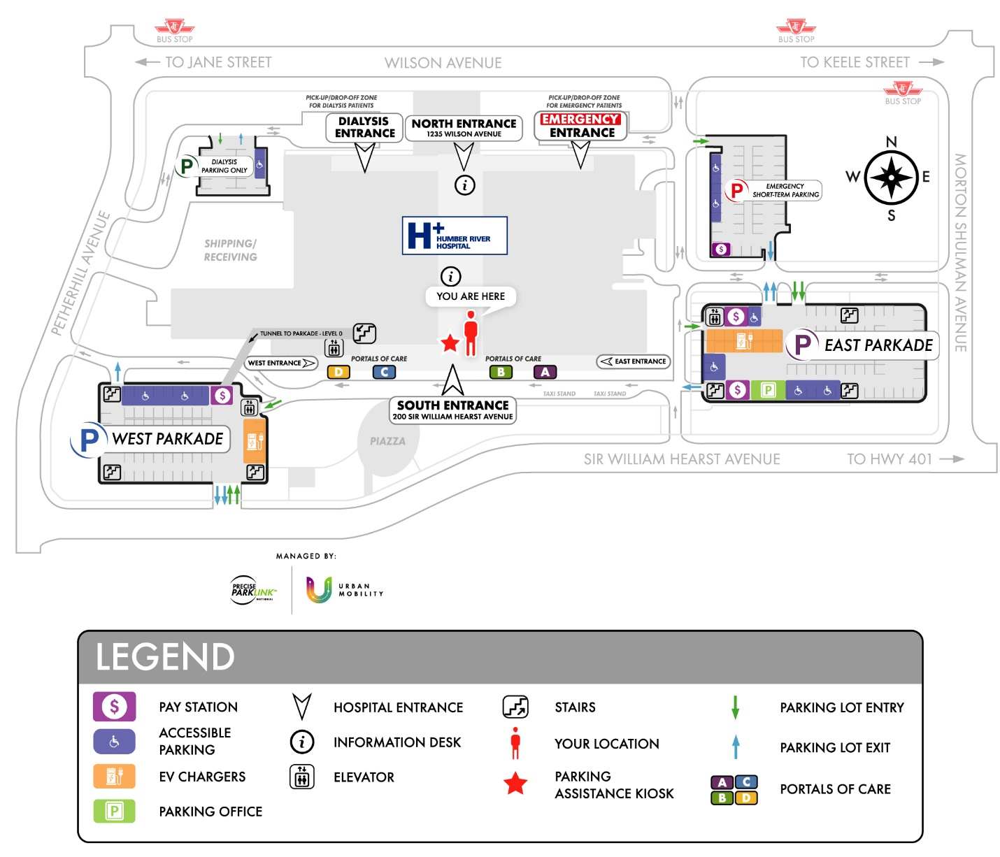

## The parking lot is full, what do I do?

Your entry ticket will allow you to exit the parking lot within 20 minutes at no charge. Please check for available parking spaces in alternative parking lots.



## Hospital portals of care.

**Portal A**

Cancer Care Level 1

Breast Health Level 2

Medical Imaging Level 2

Medical Records Level 3

Medical/Surgical Clinics Level 4

Adult Mental Health & Addictions Level 5

**Portal B**

Cardiology Level 1

Respiratory and Neurodiagnostics Level 1

South Entrance

Ambulatory Clinic Laboratory Level 1

Nuclear Medicine Level 1

Surgical Pre-screening Level 1

Surgery Level 2

Maternal & Child Level 4

Inpatient Units Levels 4 through 14

**Portal C**

Bariatric Clinic Level 1

Healthy Living Clinic Level 1

Ambulatory Procedures Level 2

Medical Day Care Level 2

Pediatric Clinic Level 4

Child & Adolescent Mental Health Level 5

**Portal D**

Fracture Clinic Level 1

Plastic Surgery Clinic Level 1

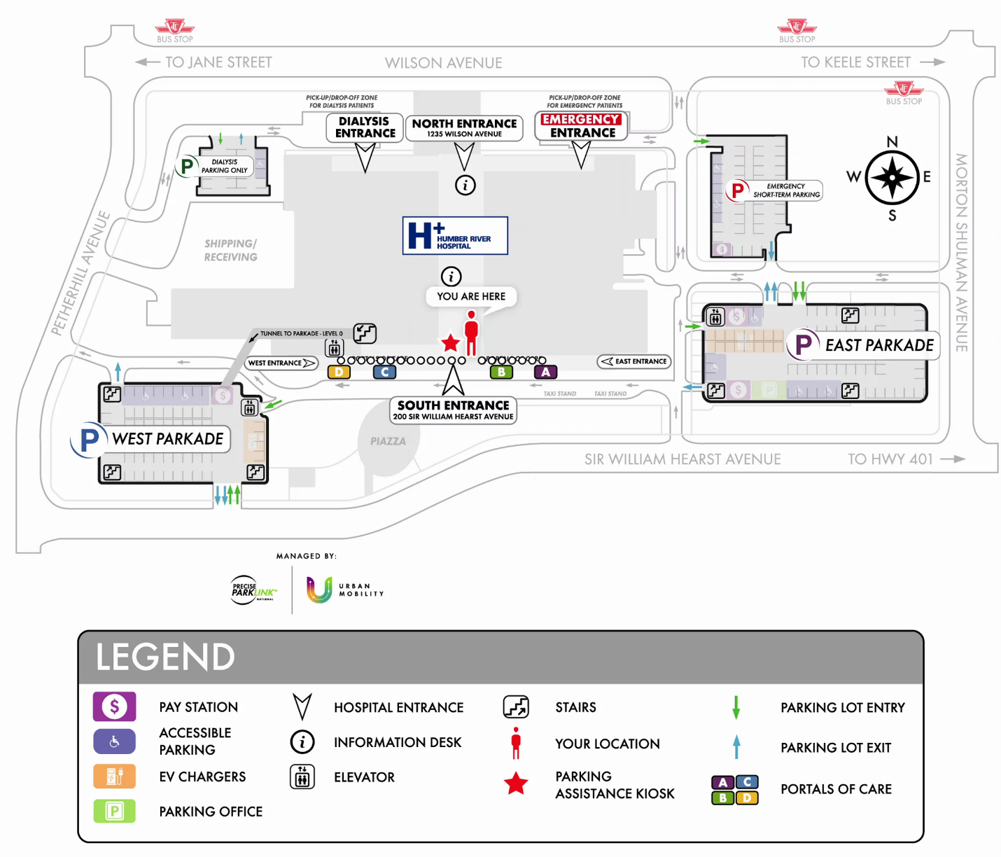

## Where are the hospital information desks located?

Hospital information desks are located between Portal B and Portal C, in the main hallways nearby the South Entrance and North Entrance (look for the orange wall).

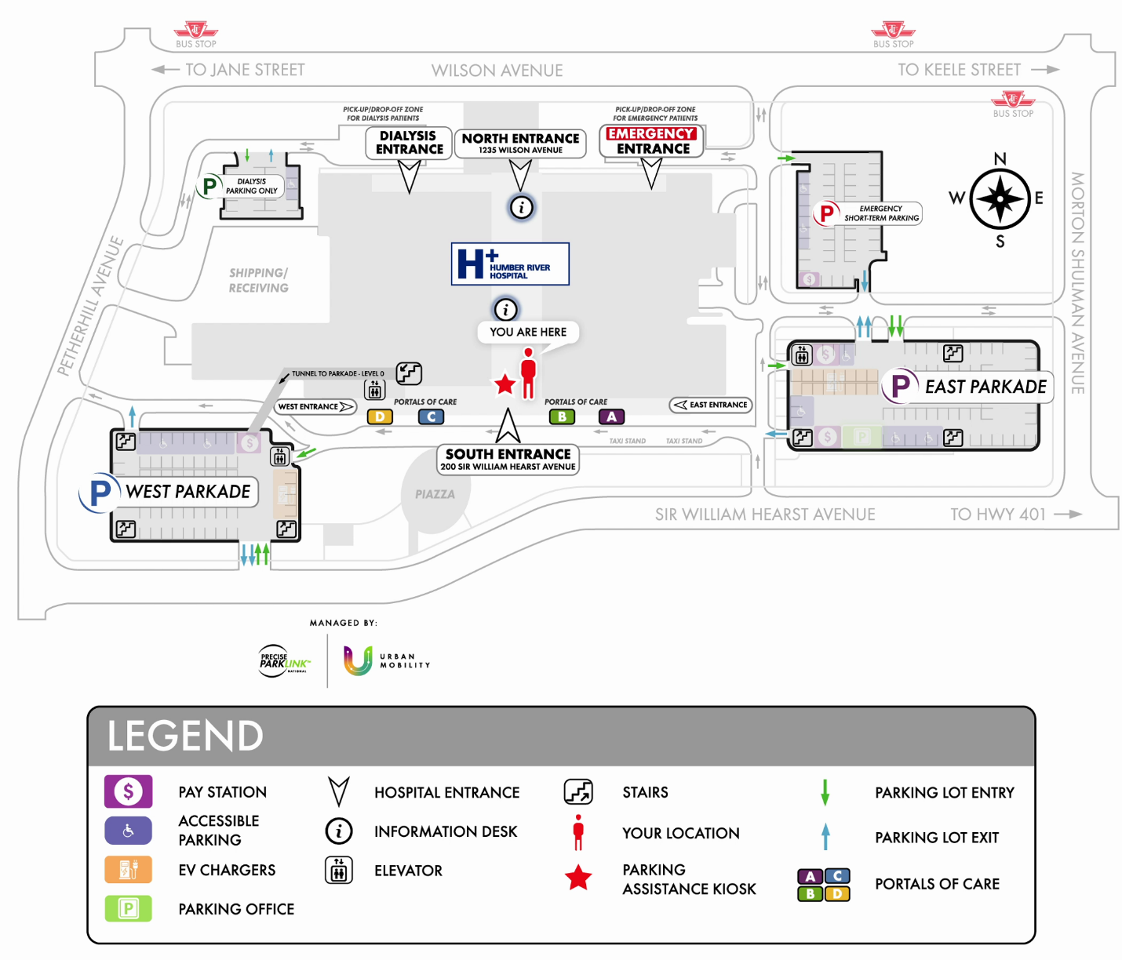

## Where does the parking revenue go?

Parking revenue is used to benefit the hospital and improve patient and visitor experiences.

# Parking Passes

## What kind of parking passes are offered?

**H PASS:**

5,10 and 30 day passes are available.

H PASS cards allow for in-and-out privileges to the parking lot and are transferrable between vehicles (only one vehicle, per pass, is permitted to be in the parking lot at a time).

**24 Hour Pass:**

This parking pass allows in-and-out privileges for 24 hours from time of entry.

**15 in/out pass:**

Allows for 15 parks (one in and out = one park). Expires one year from date of purchase.

Passes are available for purchase at the parking office or pay station. Reference the map below.

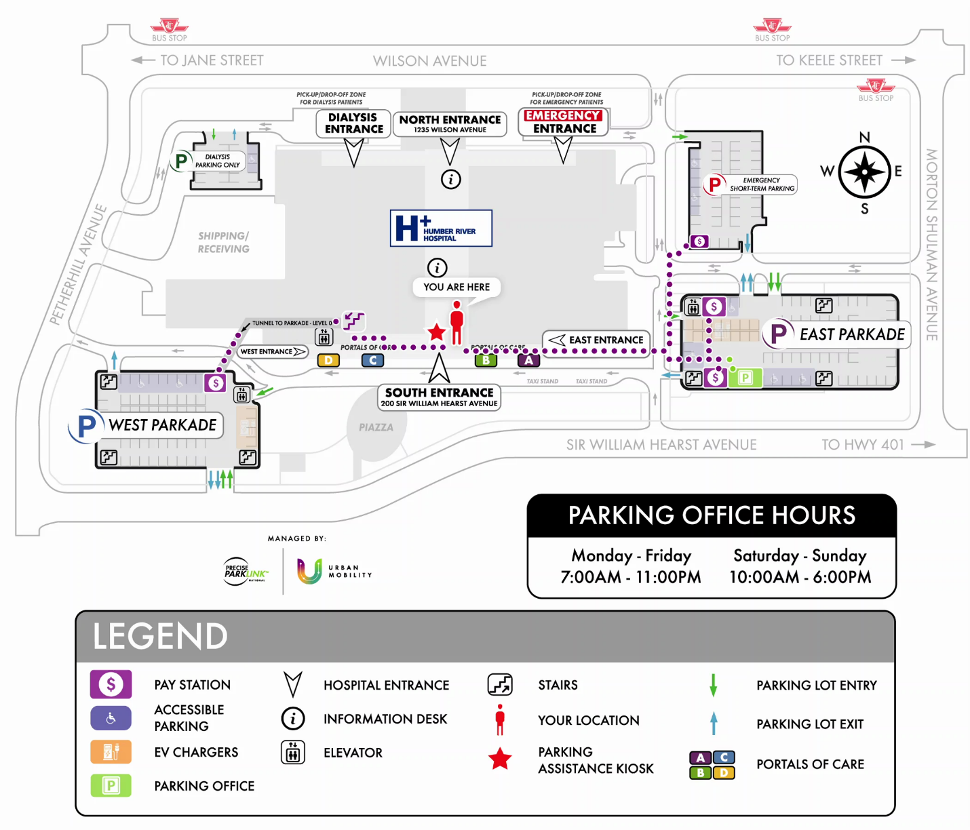

## Where can I purchase my H PASS?

You can purchase an H PASS at the parking office. The parking office is located in the southwest corner of the East Parkade.



## How many days do I have left on my H PASS?

You can check your H PASS balance by visiting www.hpasscustomer.preciserd.com and entering the digits from the back of your H PASS in the search bar.

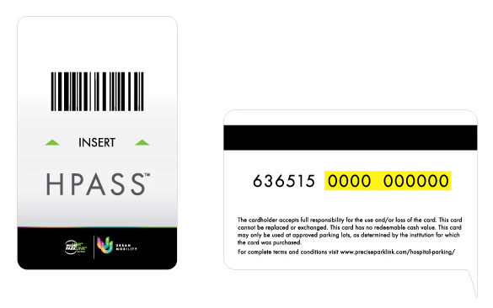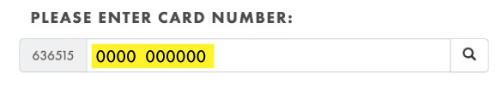

You may also visit the parking office for assistance, located in the southwest corner of the East Parkade.



## Can I reload my H PASS?

H PASS cards cannot be reloaded. If you require another H PASS please visit the parking office, located in the southwest corner of the East Parkade.



## I lost my H PASS.

Lost H PASS cards cannot be replaced. Please visit the parking office for assistance, located in the southwest corner of the East Parkade.



## I lost my 24 hour parking pass.

Lost parking passes cannot be replaced. Please visit the parking office for assistance, located in southwest corner of the East Parkade.



## I lost my 15 in/out parking pass.

Lost parking passes cannot be replaced. Please visit the parking office for assistance, located in southwest corner of the East Parkade.



## How do I use my parking pass?

All parking passes must be inserted into both the entry and exit terminal ticket slots (insert into yellow circle).

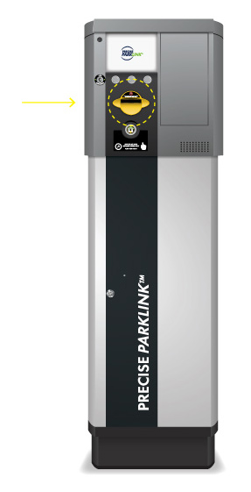

# Rates And Payments

## What are the parking rates?

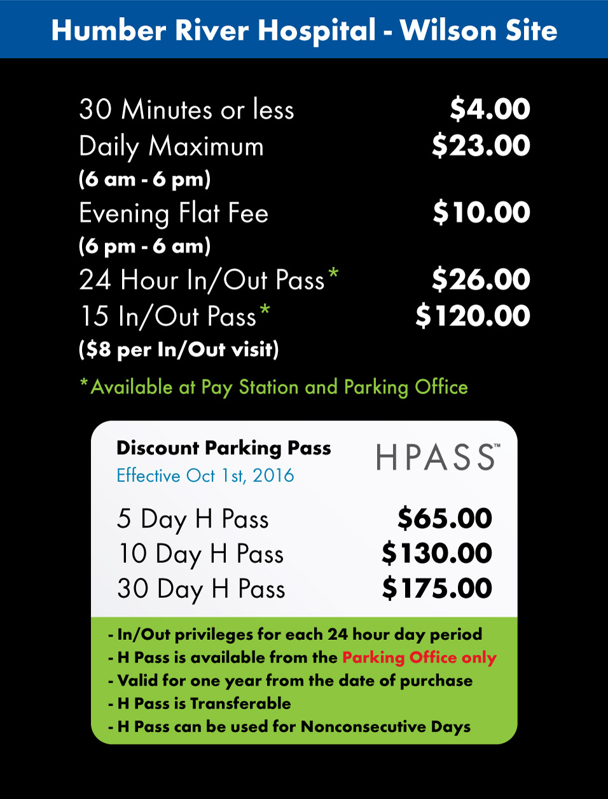

## What methods of payment are accepted?

**Parking Office and Pay Station:**

* Credit card
* Debit
* Cash

**Parking Lot Entry and Exit:**

* Credit card ONLY (no debit or interact accepted)

## Where can I pay for parking?

**Parking office and Pay Station:**

* Credit card
* Debit
* Cash

**Parking Lot Entry and Exit:**

* Credit card ONLY (no debit or interact accepted)



## Where are the pay stations located?

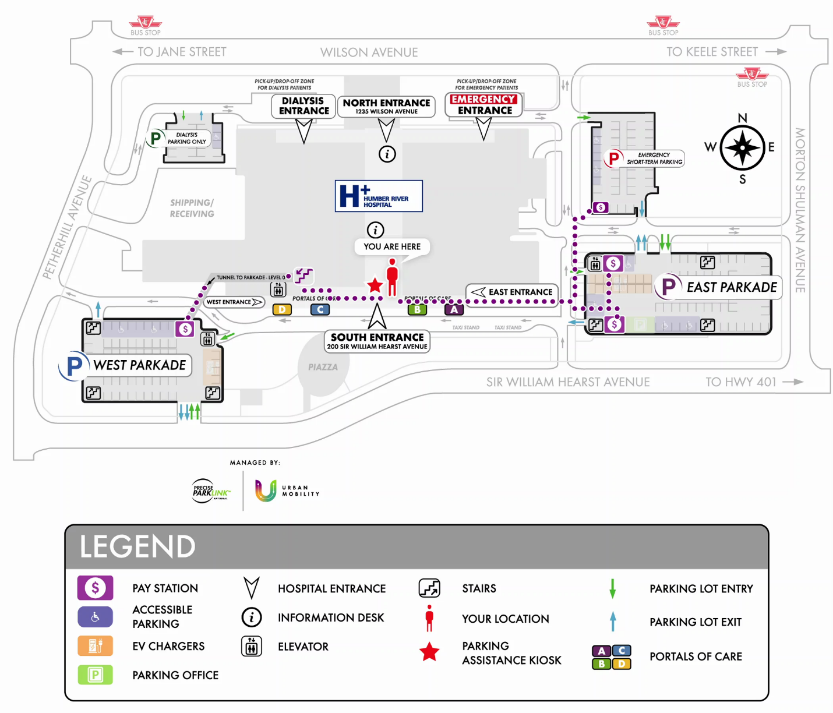

## My credit card isn't working.

Please try another credit card or pay cash or debit at the pay station or parking office.



## I lost my ticket what do I do?

Lost tickets can be purchased at the pay station or parking office.



## Where is my receipt?

Receipts are automatically dispensed from the pay station or exit terminal after payment is received.

If you did not retrieve your receipt after making payment, please visit the parking office.



## I didn't receive a ticket upon entering the parking lot.

If you entered the parking lot by tapping your credit card at the entry terminal, tap your credit card at the exit terminal to exit.

For more assistance, please visit the parking office located in the southwest corner of the East Parkade.



## Can I leave using a different credit card?

When exiting the parking lot you must use the same credit card you used to enter the parking lot.

## The machine can't read my credit card

For assistance, visit the parking office or tap the *Press for Assistance* button on the pay stations or parking lot exit terminals.

## The machine won't take bills

For assistance, visit the parking office or tap the *Press for Assistance* button on the pay stations or parking lot exit terminals.

## The machine won't take my credit card

For assistance, visit the parking office or tap the *Press for Assistance* button on the pay stations or parking lot exit terminals.

## My credit card is stuck

For assistance, visit the parking office or tap the *Press for Assistance* button on the pay stations or parking lot exit terminals.

# Help Videos

## How To Use: Gated Parking System

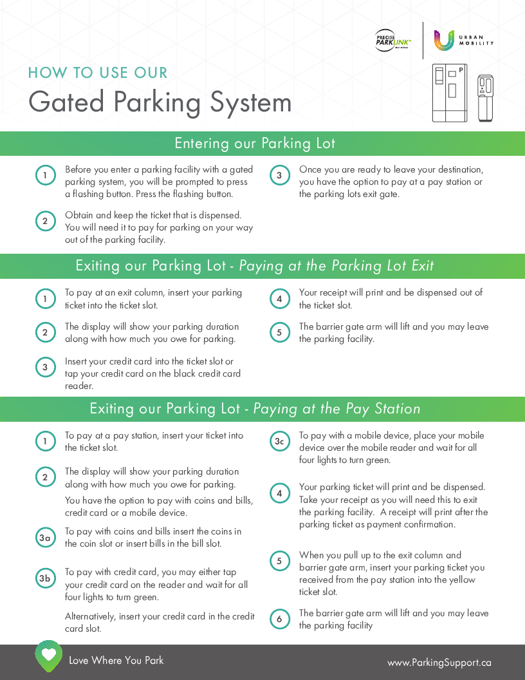

## How To Use: EV Charging Stations

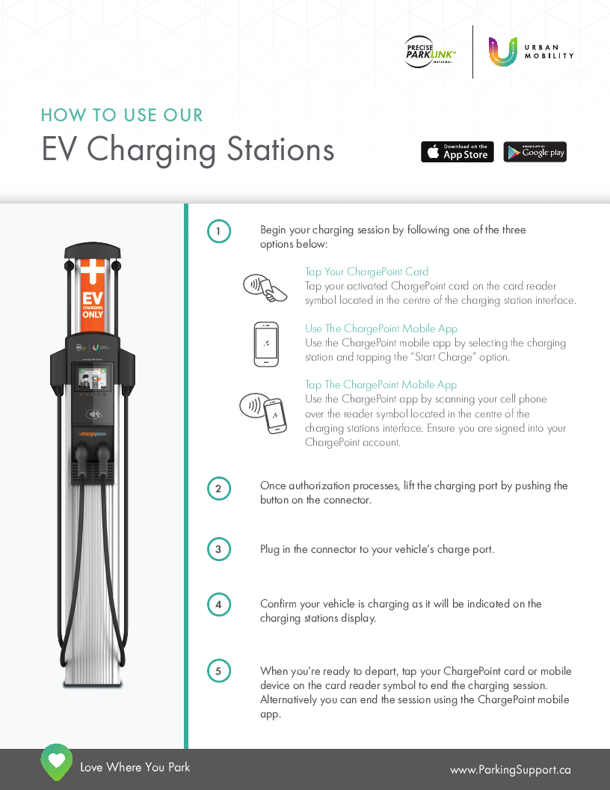

## How To Use: Pay and Display meters

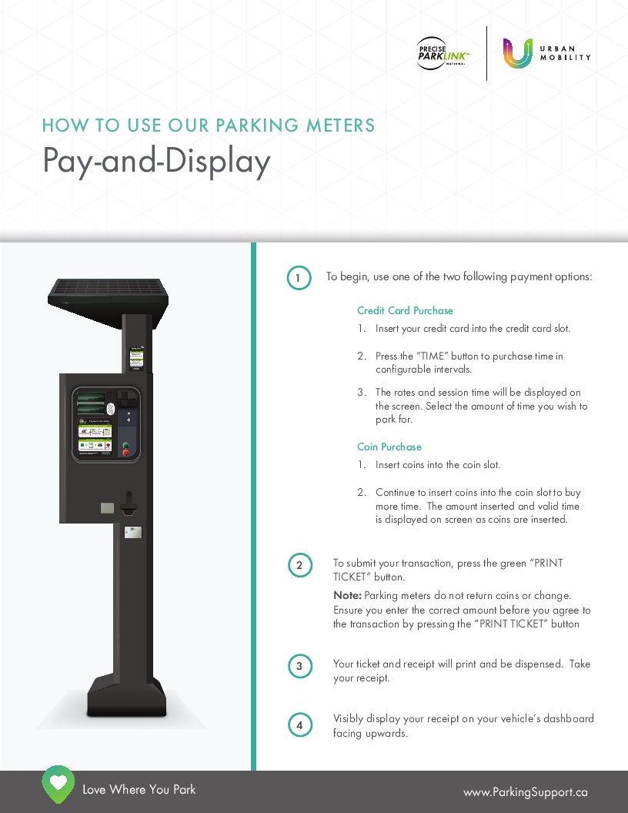

# Staff Inquiries

## Where can I park?

Hospital employees must park in the East and West Parkades.

East Parkade: Level 3 and 4.

West Parkade: Levels 2,3,4,5.

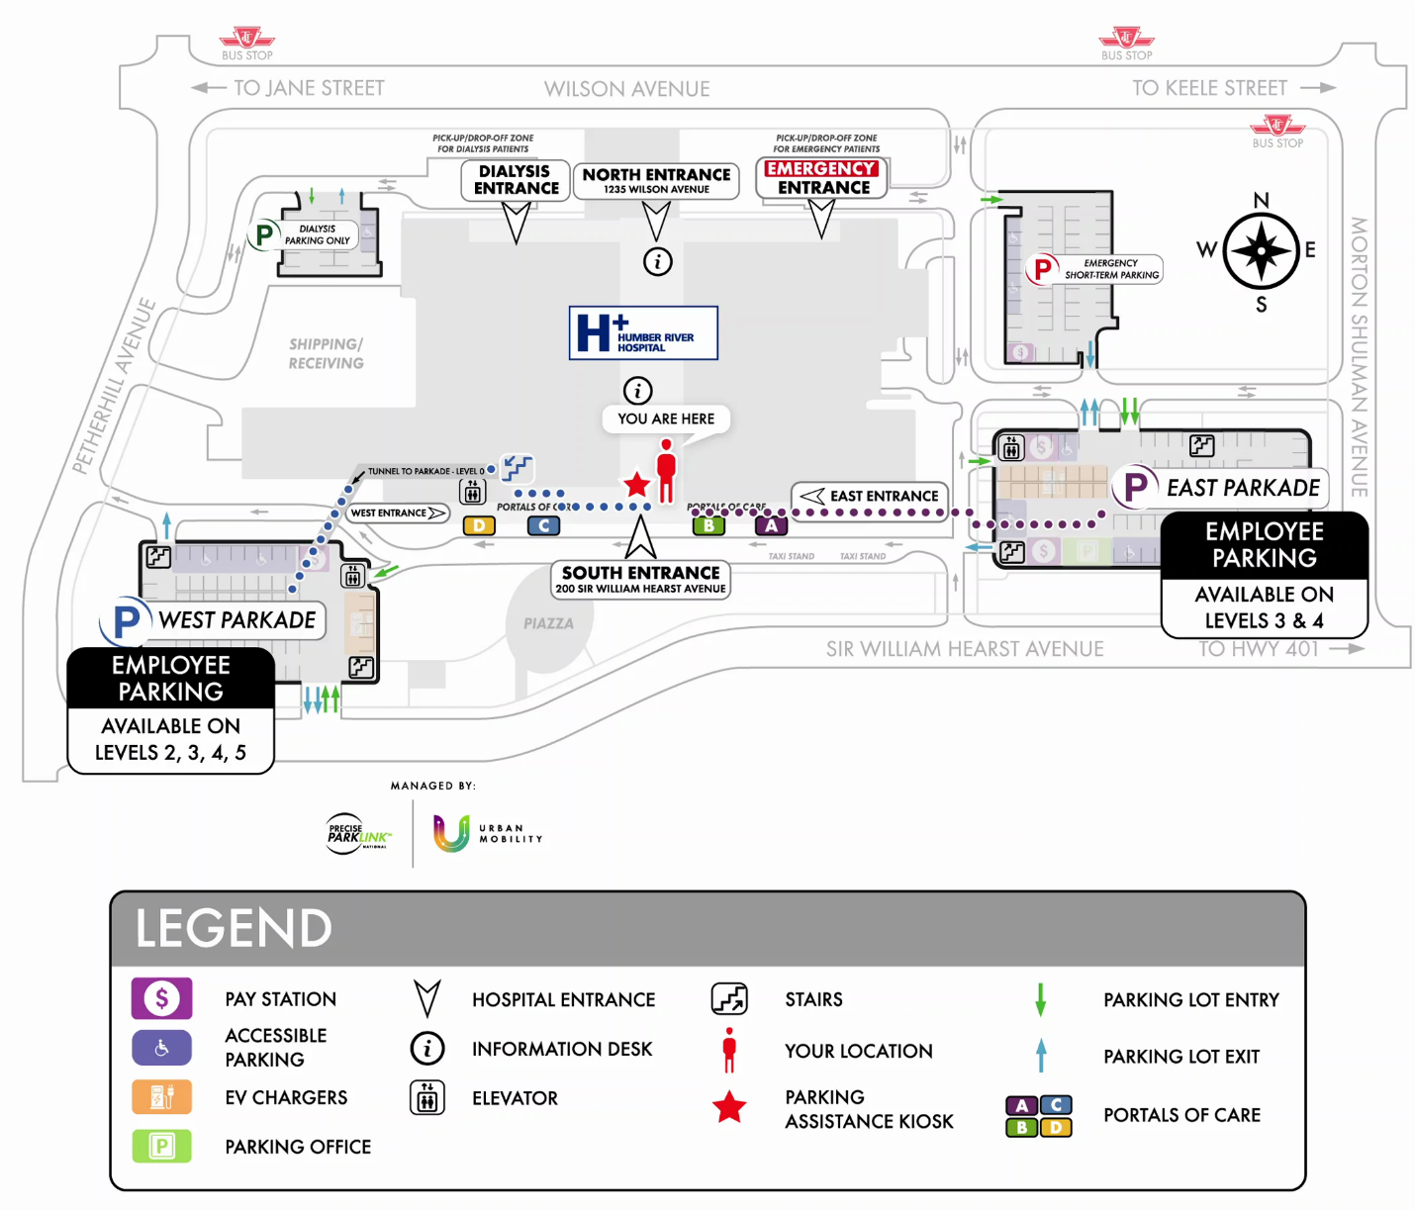

## How do I register for monthly parking (I PASS)?

Employees can register for monthly parking by calling Precise ParkLink, (416) 243-6990. Please have your hospital ID badge and credit card ready.

**Monthly parking is for hospital employees only.**